IES PILAR LORENGAR PHOTO CONTEST
MATHS IN NATURE
CATEGORY 1: SYMMETRIES (Animals, plants , landscapes, rocks...)
CATEGORY 2: MAGIC NUMBERS AND FRACTALS (Fibonacci, gold number...)
CONTEST RULES:
- The contestant must be the author of the submitted pictures (not obtained from books or the Internet).
- The contest is open to all enrolled students at the IES Pilar Lorengar.
- Each contestant may submit up to three photographies.
- JPEG format.
- Size 1600 x 1200 pixels.
- Give the photo a title. (Be inventive )
- Each photograph must be submitted (saved with its title and the name of the contestant) via email: pitagoraslorengar@gmail.com indicating the category.
- Deadline for entries: January 18, 2019.
- There will be a prize for each category that consists of a FNAC gift voucher.

IN ADDITION:
- The 10 best photographies (including the awarded ones) will participate in the IES ANDALÁN photography contest.
- An exhibition with all the entries will take place in our school, scheduled for the Cultural Week or the Maths Connection Week.

ORGANISED BY: DEPARTMENT OF BIOLOGY AND GEOLOGY AND DEPARTMENT OF MATHEMATICS.
IES PILAR LORENGAR PHOTO CONTEST
MATHS IN NATURE
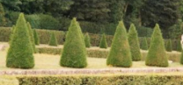
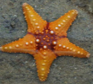
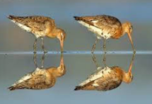
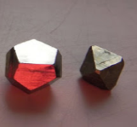
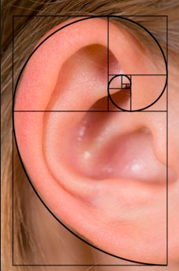
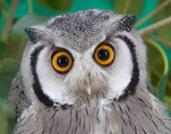
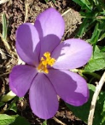
GO FOR IT!

